Job Description

Job Title: | Estates Building Assistant Manager
Hours of Work: | 37.5 per week, with occasional out of hours work as per the need of the service
Department: | Stowe School Estates
Job Grade: | 4
Accountable to: | Estates Building Manager
Number of direct reports: | Estates Foreman Painter and Building Maintenance Team  See organogram below
Budgetary responsibility: | Estates Maintenance Budget as annually advised
Location: | Stowe School  With opportunities to work on a temporary basis at the Prep Schools depending on business requirements.
Purpose of the role: | The Estates Building Assistant Manager is responsible for the safe and efficient delivery of building maintenance and small building projects to the buildings and facilities at Stowe School, ensuring that project, budget and programme objectives are achieved and that all relevant legislation and best practice is followed.  They will directly manage the Building Maintenance team and the Estates Foreman Painter and will provide support to all other Estates team members and stakeholders.  The Estates Building Assistant Manager role is as illustrated by the team structure in the following organogram.
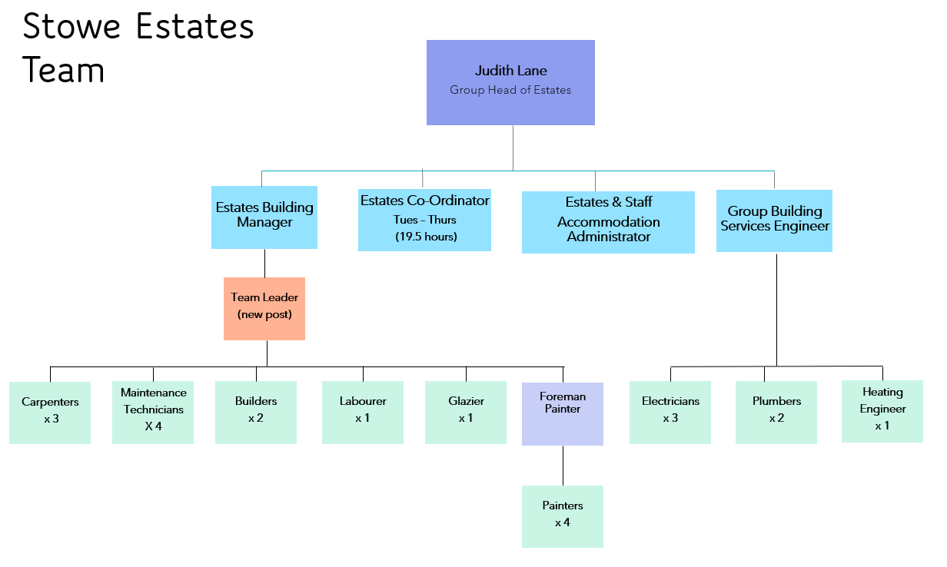

The Stowe Group
The Stowe Group of schools (Stowe, Swanbourne House and Winchester House) was created in January 2021 and is situated on three separate sites in Buckinghamshire and Northamptonshire. Across the three schools, The Stowe Group offers education for boys and girls from 3-18 years. Within The Stowe Group there are more than 1,500 pupils and 850 colleagues. The Schools occupy sites of historical significance in Swanbourne, the market town of Brackley and the world-famous landscape gardens at Stowe, where we work with The National Trust to manage 880 acres and open the grounds to over 200,000 visitors a year. Stowe House is open to the public during the School holidays and for guided tours during term time. The Stowe Group is committed to safeguarding and promoting the welfare of children and expects all staff to share this commitment. In 2021, The Stowe Group launched its transformational and substantive Change Makers vision and Change 100 programme.

Vision & Ethos
We are Change Makers

Stowe stands in the most sublime setting of any school in the world. Historic buildings, landscaped gardens and the very spirit of the Enlightenment sit at the heart of its founding. But, as this remarkable landmark enters its second century as a leading public school, we believe that beauty and tradition are not enough: our future vision for the School embraces change, uncertainty and the challenges that will face our pupils not just during their academic careers, but throughout the rest of their lives in a world which is increasingly complex and ambiguous. Within that volatile environment we see our pupils and staff as Change Makers. They will make a lasting impact not only while they are here at Stowe, but, perhaps more importantly, in the wider world. The history of this place, both as a stately home and as a pioneering school remains important to our mission of education, and at the heart of a Stowe education remains intellectual enquiry, academic curiosity and a love of learning. We strive for a balance of rights and responsibilities, equality and inclusion and to treat each pupil and member of staff as an individual. Our vision is inspired by a history of progressive thinking, and has been developed through collaboration with our pupils, parents, teachers, support staff, governors and alumni. Yes, we teach pupils how to excel in exams, but we also teach them how to collaborate, how to solve problems and how to think critically. Stowe is educating a generation of Change Makers ready to transform the world.

The Group’s talented and committed workforce is one of our greatest strengths. We are committed to fostering team engagement, attracting, mentoring, developing and retaining our best teachers and support staff. We focus on employee wellbeing, provide opportunities for professional growth and we create a culture of community and partnership.

Key Tasks:
To assist the Group Head of Estates, the Estates Building Manager and the Estates teams to ensure that the upkeep and statutory compliance of all buildings and infrastructure in and around the school and any other properties that the school may have at their disposal, are fully maintained.

To report to and support the Estates Building Manager to ensure that the Stowe Estate is maintained to very high standard, and to provide high quality services to all members of the Stowe Group Community.

To support and manage the Estates Foreman Painter and the Buildings Maintenance Team, to ensure that the Stowe Estate is kept fully maintained to a high level of presentation and statutory compliance, and that all works are cost effective and undertaken within agreed programmes. Prepare and manage work plans.

To note the repairs and work identified on the works portal, and via the annual project programme, and in conjunction with the Estates Foreman Painter and the Buildings Maintenance Team ensure that works are prioritised and completed within budget and programme.

Ensure that department risk assessments are kept up to date and relevant, and that the risk assessment process is fully adhered to.

Oversee and manage budgets as directed by The Group Head of Estates and provide financial reports as requested.

Ensure that the Decoration and Buildings Maintenance Team operate fully in compliance of all Stowe Group Policies, including but not limited to Asbestos, Fire Safety and Safeguarding.

To support the Estates Building Manager in undertaking Building Condition Surveys and inspections of the Stowe Estate, and jointly develop and annually review Planned Preventative Maintenance Schedules.

Assist the Estates Building Manager with the preparation and submission of written and financial reports as required.

Assist the Estates Building Manager with the management and upkeep of the Stowe Residential Accommodation Portfolio, including carrying our tenancy inspections, arranging repairs, and working with group stakeholders to ensure that landlord responsibilities are met.

To assist the Estates Building Manager with the management of the asbestos register and to ensure that all asbestos management processes are followed by the Building Maintenance and Decoration teams

To deputise for the Estates Building Manager at meetings as required.

To attend Operational Meetings as arising, provide reports for the same as required.

To undertake daily work briefings with the Estates Decoration Foreman and the Building Maintenance team, ensure that all daily and project risk assessments are undertaken, ensure that safe work practices are always undertaken, and ensure that the Permit to Work process is followed, and any other relevant processes and procedures.

For small building projects (up to circa £100K) prepare feasibility studies and project plans, prepare funding requests, and prepare tender documentation, including Preliminaries, Preambles, Scope of Works/ Designs and tender invitations. Request quotations and prepare tender analysis reports. Appoint external contractors and / or develop an in-house project team. Contract administer the works in accordance with the JCT Minor or Intermediate Form of Contract, ensuring statutory compliance, build quality and programme adherence. Undertake project preparation and progress meetings and prepare minutes of the same. Have financial accountability for the project, manage budgets, agree Final Account and undertake valuations. Keep electronic records, programmes and trackers of all processes and actions.

Ensure full adherence with the CDM Regulations 2015, and any subsequent health and safety legislative changes. Undertake the role of Principal Designer and/or Principal Contractor, prepare Pre-Construction Information Packs for minor projects, and Construction Phase Plans for in-house projects.

Liaise with external contractors, review and assess Risk Assessments and Method Statements for contractors, request and respond to changes and updates.

Carry out building and health and safety inspections and provide reports as required

Work with stakeholders, statutory authorities, the local authority, the National Trust and other third parties in a collaborative manner, attend meetings with the same as required.

Ensure that allocated budget is used effectively across the financial year, and that any potential overspend is notified to the Estates Building Manager in good time.

Prepare Planning, Listed Building Consent and Building Control applications for minor projects and achieve approval of the same. For complicated projects work with external stakeholders in the preparation and achievement of Listed Building Consent applications, Planning applications and Building Control applications.

Oversee the fire door audit programme, ensure that records are fully maintained, and that repairs and remedial works are undertaken within programme and budget.

To assist the Estates Building Manager in the development of Term Contracts, procurement and analysis of the same, and annual reviews.

To ensure that all statutory inspection, processes and procedures are undertaken by the team and correctly recorded.

To carry out all work in a professional manner, and fully in accordance with the appropriate standards and legislation.

To follow all health and safety instructions for work activities and for using vehicles, plant and equipment if required, report any health and safety concerns or faults immediately to the designated manager. Drive the Stowe vehicles as required and adhere to the driving policy.

Ensure that building statutory compliance and best practice is always fully maintained.

Undertake appraisals, set and review objectives for the Estates Foreman Painter and the Building Maintenance Team.

Oversee the training matrix for the Decoration and Building Maintenance Teams, review all training needs and ensure that training requirements are maintained.

Assist the Estates Foreman Painter and the Buildings Maintenance team in ensuring that the legal provisions relating to Health and Safety at work are properly adhered to, including the safe storage of any flammable/toxic substances on site (excluding teaching workshops/laboratories)

Liaise with maintenance and product suppliers as required.

To use as effectively as possible ICT and be open to developing new ICT strategies to improve efficiency.

Undertake any other work as reasonably requested by the Head, the Group Head of Estates, or the Estates Building Manager

On occasions and as required visit one of the Group Prep Schools or off-site properties to aid and support. Enrol on the company Grey Fleet and use a company pool vehicle if available, or personal vehicle, provide insurance business cover for the latter. Comply with Stowe driving policies.

To be aware of, and comply with, the policies and procedures relating to safeguarding, health and safety and security.

Stowe Group is committed to safeguarding and promoting the welfare of children and young people and expects all staff to share this commitment. The post holder’s responsibility for promoting and safeguarding the welfare of children and young persons for whom he/she comes into contact will be to adhere to and always ensure compliance with the Stowe Group’s Child Protection Policy Statement.

Person Specification: The selection of candidates for short-listing will be based on this specification and candidates should bear this in mind when preparing their application and completing the application form
Attributes | Essential | Desirable
Qualifications | - Educated to higher education level in a relevant discipline (minimum HND/HNC or equivalent)  - Qualified to work in the UK  - A full, clean driving licence | - MCIOB  - SMSTS  - Level 6 NVQ in Site Management  - NEBOSH  - Asbestos Awareness  - Fire Safety  - Legionella awareness
Specialist Skills and Experience | - Good demonstrable building technical knowledge  - Good demonstrable knowledge of the CDM Regulations  - Previous experience in building / construction management and leading a team  - Ability to diagnosis building defects, specify repairs and manage remedial works.  - Ability to respond to a brief, prepare a design, and project manage small construction works.  - Knowledge and experience of contract administration and project management duties and responsibilities, from Project Feasibility to Final Account  - Proven track record of budget management.  - Knowledgeable of Health and Safety regulations pertinent to the areas of responsibility, including the CDM Regulations 2015  - Ability to work in a fast-paced environment and to multi-task.  - Proven ability to work to high standards.  - Good written and reporting skills.  - Strong skills for Word, Excel and Outlook | - Previous experience working in a similar position in a school or similar  - Previous experience supporting a school or similar in delivering building maintenance.  - Knowledge of Building Regulations, Planning Permissions and Listed Building Consent  - Experience of undertaking the role of Principal Designer / Principal Contractor  - Good IT skills other than Word, Excel and Outlook  - Familiar with JCT Form of Contracts
Personal Qualities | - Good organisational skills with the ability to prioritise, plan, and organise your own workloads effectively to achieve objectives.  - Good management skills and an ability to encourage a team to deliver their best.  - Be able to work without supervision but also know your own limitations.  - Hard working, punctual and reliable.  - Diplomatic and tactful.  - Fluency in written and spoken English.
This job description and Person Specification reflects the present requirements of the post and as duties and responsibilities change/develop, the job description will be reviewed and be subject to amendment in consultation with the post holder
Date Agreed: August 2024

Our Values

Value scales:
This value is the least important to the role | This value has some significance to the role | This value is desirable to the role but not essential | This value is important to the role | This value is essential to the role
1 | 2 | 3 | 4 | 5

In the role of Estates Building Assistant Manager, we are looking for Change Makers who are (please highlight as appropriate):

Professional: | 1 | 2 | 3 | 4 | 5
Creative Problem Solvers: | 1 | 2 | 3 | 4 | 5
Kind: | 1 | 2 | 3 | 4 | 5
Flexible: | 1 | 2 | 3 | 4 | 5
Collaborative: | 1 | 2 | 3 | 4 | 5
Communicator: | 1 | 2 | 3 | 4 | 5

