Job Description

Job Title: | Group Project Manager
Hours of Work: | Approximately 37.5 hours per week (or as required)
Department: | Estates
Job Grade: | 1
Accountable to: | Group Director of Estates
Budgetary responsibility: | Yes
Location: | Stowe (with travel across School sites)
Purpose of the role: | To deliver new build and complex refurbishment projects with values ranging from £250K to £10m across the Stowe Group.  To appoint and manage external consultants and contractors throughout the project life cycle; ensuring that projects are delivered on time, in budget and to the agreed specification.
The Stowe Group
The Stowe Group of schools (Stowe, Swanbourne House and Winchester House) was created in January 2021 and is situated on three separate sites in Buckinghamshire and Northamptonshire. Across the three schools, The Stowe Group offers education for boys and girls from 3-18 years. Within The Stowe Group there are more than 1,500 pupils and 850 colleagues. The Schools occupy sites of historical significance in Swanbourne, the market town of Brackley and the world-famous landscape gardens at Stowe, where we work with The National Trust to manage 880 acres and open the grounds to over 200,000 visitors a year. Stowe House is open to the public during the School holidays and for guided tours during term time. The Stowe Group is committed to safeguarding and promoting the welfare of children and expects all staff to share this commitment. In 2021, The Stowe Group launched its transformational and substantive Change Makers vision and Change 100 programme.
Vision & Ethos
We are Change Makers

Stowe stands in the most sublime setting of any school in the world. Historic buildings, landscaped gardens and the very spirit of the Enlightenment sit at the heart of its founding. But, as this remarkable landmark enters its second century as a leading public school, we believe that beauty and tradition are not enough: our future vision for the School embraces change, uncertainty and the challenges that will face our pupils not just during their academic careers, but throughout the rest of their lives in a world which is increasingly complex and ambiguous. Within that volatile environment we see our pupils and staff as Change Makers. They will make a lasting impact not only while they are here at Stowe, but, perhaps more importantly, in the wider world. The history of this place, both as a stately home and as a pioneering school remains important to our mission of education, and at the heart of a Stowe education remains intellectual enquiry, academic curiosity and a love of learning. We strive for a balance of rights and responsibilities, equality and inclusion and to treat each pupil and member of staff as an individual. Our vision is inspired by a history of progressive thinking, and has been developed through collaboration with our pupils, parents, teachers, support staff, governors and alumni. Yes, we teach pupils how to excel in exams, but we also teach them how to collaborate, how to solve problems and how to think critically. Stowe is educating a generation of Change Makers ready to transform the world.

The Group’s talented and committed workforce is one of our greatest strengths. We are committed to fostering team engagement, attracting, mentoring, developing and retaining our best teachers and support staff. We focus on employee wellbeing, provide opportunities for professional growth and we create a culture of community and partnership.
Responsibilities and accountabilities:
- Reporting to the Group Director of Estates to be responsible for the delivery of complex refurbishment and new build projects as instructed, including obtaining all relevant statutory approvals.

- To evaluate, appoint and manage external consultants including Architects, Quantity Surveyors, M&E Consultants, Health and Safety Advisors and where appropriate external Project Managers, and to act as the Client’s representative.

- To lead the procurement of projects including the tender process and selection of contractors. Thereafter to manage the budget and all reporting.

- To act as the key liaison with stakeholders in the Group delivering communication in a timely and efficient manner ensuring that the delivered project is in line with their requirements.

- To ensure compliance with and have a detailed understanding of all relevant Health and Safety and CDM regulations.

- To have a good understanding of construction contracts and processes.

Key Tasks:
- Provide support and work alongside colleagues from across the Group in the production of feasibility studies, project plans, and funding requests, to enable projects to be presented for Governors’ approval, and to enable project development.
- To appoint and manage consultants and contractors, including health and safety, financial and suitability assessments, and to act as the Client representative.
- To oversee the construction/ complex refurbishment works as instructed to deliver the projects in the agreed timeframes and budgets. Undertake project preparation and progress meetings and prepare minutes of the same. Have financial accountability for the project and manage budgets.
- Where a consultant is not appointed, contract administer the project, agree Final Account and undertake valuations, provide all necessary certification.
- In all instances keep electronic records ensuring that the electronic ‘library’ of project data is fully maintained, programmes and trackers of all processes and actions. ensuring statutory compliance, build quality and programme adherence.
- To ensure full Planning and Listed Building applications are made and Building Regulations and any other necessary Statutory applications are applied for in a timely manner with all agreed and adhered to. To include all supplementary reports and liaison with representatives as required.
- To ensure the agreed project management methods, standards and processes are maintained throughout the project lifecycle.
- To carry out routine inspections and ensure any remedials or additional works are authorised and delivered.
- To develop and support effective communication mechanisms between the stakeholders including Governors and external appointments.
- To ensure all Health, Safety and Compliance paperwork is in place for each project including method statements, risk assessments, Permits to Work, Safe Systems of Work and compliance with CDM regulations.
- To have a good understanding of the risks and management processes associated with asbestos and ensure that all procedures are implemented in accordance with statutory and policy requirements. Work collaboratively with the Estates team to ensure that the Asbestos Register is kept up to date.
- To liaise with the Finance Department on cross charges and provide allocation of invoices and orders to budget codes.
- To work collaboratively with the other Estates team members within the Group. Provide support and advice to the Prep School Estate Managers and attend Heads of Department meetings.
- Include the Estates team members within the design and implementation of projects, ensure that commissioning and hand over information is provided within a timely manner, and that any latent defects are addressed.
- Support the Group Director of Estates in the delivery of a safe environment for all users.
- Support the Group Director of Estates in communications with partner bodies, including the National Trust, Stowe House Preservation Trust and Stowe Enterprises Ltd, provide project reports as required, attend meetings and liaise with partner representatives as required.
General Duties
- To ensure adherence to statutory Health and Safety and Data Protection Legislation at all times. To carry out other tasks as can be reasonably expected in line with the role of Group Project Manager.

Person Specification: The selection of candidates for short-listing will be based on this specification and candidates should bear this in mind when preparing their application and completing the application form
Attributes | Essential | Desirable
Qualifications | - HND/HNC Construction Management/Project Management. | - Professional qualification with RICS/ CIOB.
Specialist Skills and Experience | - Proven track record of multiple projects covering construction and refurbishments within an active operational environment.  - Experience of managing projects up to £10m across complicated buildings.  - Understanding of Planning and Listed Building Consents.  - Understanding of CDM Regulations.  - Understanding of asbestos management legislation.  - Understanding of construction programmes and contracts.  - Instructing and managing external consultants.  - Clear thinking and able to make strategic and tactical decisions to progress the project within the constraints set. | - Worked within an educational environment.  - Worked within a Listed Building or Heritage setting.  - Understanding of leases
Personal Qualities | - Strong leadership approach, engendering collaborative and innovative ways of working.  - Positive communication skills to motivate project team and develop a strong rapport with project stakeholders.  - Tact and diplomacy in order to get the co-operation of all parties.  - Emotional intelligence.  - Collaborative working practices.  - Positive attitude and ability to work independently.  - Strives for excellence. | - Safeguarding experience (including leading complaint investigations).
This job description and Person Specification reflects the present requirements of the post and as duties and responsibilities change/develop, the job description will be reviewed and be subject to amendment in consultation with the post holder
Date Agreed: November 2024

Our Values
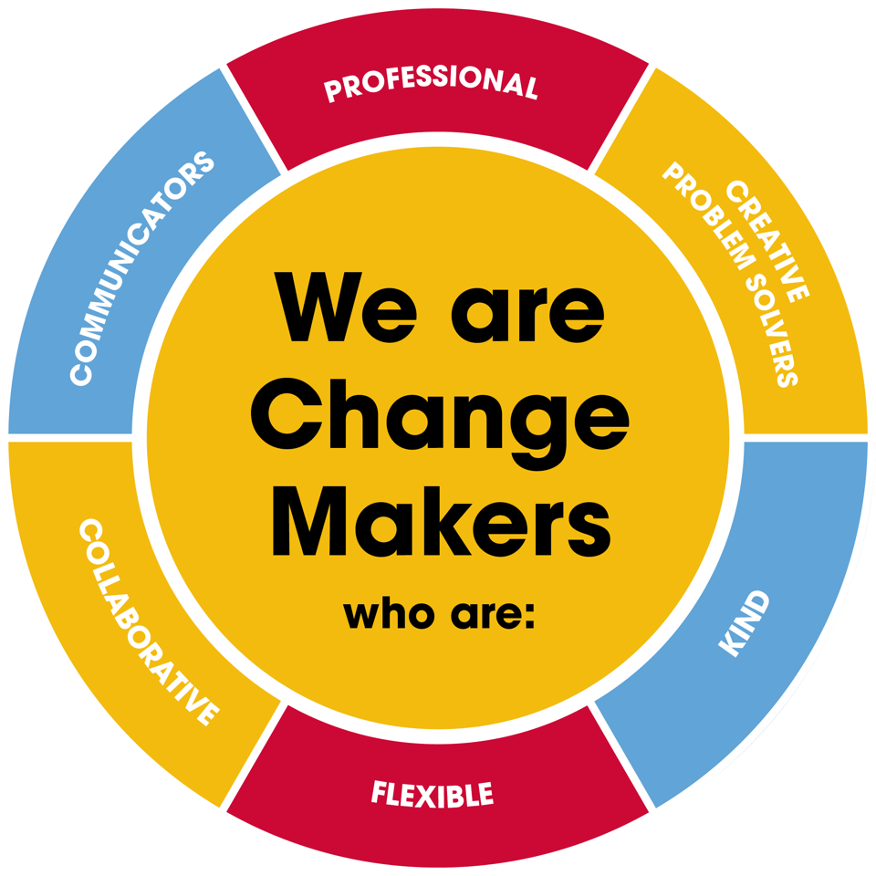
Value scales:
This value is the least important to the role | This value has some significance to the role | This value is desirable to the role but not essential | This value is important to the role | This value is essential to the role
1 | 2 | 3 | 4 | 5

In the role of Group Project Manager, we are looking for Change Makers who are (please highlight as appropriate):

Professional: | 1 | 2 | 3 | 4 | 5
Creative Problem Solvers: | 1 | 2 | 3 | 4 | 5
Kind: | 1 | 2 | 3 | 4 | 5
Flexible: | 1 | 2 | 3 | 4 | 5
Collaborative: | 1 | 2 | 3 | 4 | 5
Communicator: | 1 | 2 | 3 | 4 | 5

